Running head: Response inhibition and distance perception

Perceptual and behavioral adjustments after action inhibition

Wladimir Kirsch and Wilfried Kunde
Department of Psychology, University of Würzburg, Germany

Corresponding author:
Wladimir Kirsch
Institut für Psychologie III der Universität Würzburg,
Röntgenring 11, D-97070 Würzburg, Germany
E-Mail: kirsch@psychologie.uni-wuerzburg.de
Tel.: ++49 931 31 82191
Fax.: ++49 931 831 2815

Abstract
Inhibiting a motor action typically prompts a more cautious action mode leaning towards accuracy rather than speed. In the present study we explore if action inhibition is also accompanied by changes of visual perception. Participants performed goal directed hand movements from a start to a target position and then judged the start-target distance. In a proportion of trials, movement execution had to be stopped before the target position was reached. The results of two experiments revealed smaller start-target distance estimates after interrupted than after unrestricted movements. Moreover, movement amplitude decreased in movements that followed interrupted ones. In line with predictions of action specific accounts of perception this outcome indicates that subjective perceptual changes might inform how to plan future actions.

Introduction
A key characteristic of human behavior is its high flexibility. For instance, we are able to inhibit a planned or even already initiated action when necessary. Such response suppression often results in adaptive adjustments of subsequent behavior as demonstrated by several reaction time experiments (see Verbruggen & Logan, 2008 for a review). In the widely used stop-signal paradigm (e.g., Logan & Cowan, 1984) participants typically perform a visual discrimination task that requires a speeded response (“go trials”). On some trials an auditory stop signal is presented which asks participants to withhold their response (“stop trials”). Typically responses after previous stop trials are slower than after previous go trials (e.g., Verbruggen, Logan, Liefooghe, & Vandierendonck, 2008). Thus, after a stop trial, participants strategically slow down their go responses to increase the probability of potential stopping (cf e.g., Bissett & Logan, 2011; Bissett & Logan, 2012).
In the present paper we explored if requirements to stop ongoing actions are accompanied by changes of perception. Such changes are suggested by action specific accounts of perception (see Witt, 2011a; Proffitt, 2008; Proffitt & Linkenauger, 2013 for reviews). These accounts hold that perception is based upon a reference of initial optical information to motor variables that are relevant for intended actions. Accordingly, changes in motor variables can give rise to changes in visual perception in spite of a constant stimulus. Using a tool extending one’s reaching ability, e.g., proved to decrease an egocentric distance to a target object (Witt, 2011b; Witt & Proffit, 2008; Witt, Proffitt, & Epstein, 2005). Of a particular importance for the present study is the claim that (action specific) perception prepares the perceiver for a subsequent action by signaling opportunities and costs associated with that action (e.g., Proffitt, 2006; Witt, 2011a). For example, encumbering a person with a heavy backpack has been reported to let hills look steeper. This change of perception might help to select an appropriate speed of walking and to avoid excessive demands. Seeing a target as smaller after an unsuccessful attempt to hit it may help to exert additional resources in a subsequent attempt. Thus, it is conceivable that cognitive adjustment processes are accompanied by changes of visual perception to facilitate subsequent adaptive behavior.
Some indirect support for this assumption comes from studies which examined the impact of optical illusions on motor behavior (Witt, Linkenauger, & Proffitt, 2012; Wood, Vine, & Wilson, 2013). The authors reported improved performance in a putting task when smaller context stimuli surrounded a hole as compared with larger context stimuli. Witt et al. (2012) suggested that if the target appears bigger (in case of small context stimuli) the actor improves performance because s/he might expect to be more able to hit the target (that appears to be easier to hit). These results indicate that changes in perception can be associated with, and possibly cause, behavioral adjustments.
We explored this issue using a stop signal task. Participants repeatedly performed a hand movement aiming at a target and subsequently judged a given target distance. In one half of the trials a stop-signal was presented during the movement. In response to this signal the ongoing movement had to be interrupted. Alike the classical stop-signal paradigm, movement interruption can be assumed to entail adjustments in the planning and control of subsequent movements (cf also e.g., van Beers, 2009). In particular, after a stop trial participants should be more cautious during planning and control of the next movement in order to increase chances of potential stopping. This can be achieved by a decrease of applied forces (e.g., of peak force or of the rate of force development). Thus, the parameters of a given movement can be expected to vary depending on whether the previous movement was stopped or not. The primary question of interest was whether these performance adjustments are preceded by perceptual changes that come with such an adaptive behavior.
In previous studies we showed that parameters of planned movements, such as amplitude, direction and force, in fact affect visual perception (Kirsch, Herbort, Butz, & Kunde, 2012; Kirsch & Kunde, 2013a; Kirsch & Kunde, 2013b; Kirsch & Kunde, 2014). Planning a movement of large (as compared with small) amplitude, e.g., proved to increase the perceived target distance (e.g., Kirsch et al., 2012). These results thus indicate that when changes in planning of an action occur, changes in visual perception of action relevant objects can be expected. Accordingly, if planning a movement following movement interruption in the present setup differs from planning a movement following an unrestricted movement, then differences in the perception after interrupted and unrestricted movements could emerge. In particular, planning a movement associated with a smaller force impulse following movement interruption is expected to decrease the distance estimate as compared with planning a larger force impulse following an unrestricted movement.
In other words, movement interruption might cause strategic adjustments of the initial movement plan resulting in a tendency to slow down the subsequent movement. During the target perception measured after movement interruption this adjusted motor plan can then be used as a reference for optical information. Accordingly, apparent target distance should decrease following stop trials as compared with trials including unrestricted movements. This would correspond with the signal function ascribed to the perception. Because a decrease in target distance typically prompts movements with smaller amplitudes and initial forces (e.g., Gordon & Ghez, 1987; Messier & Kalaska, 1999) a decrease in perceived distance after movement interruption would lead to more cautious behavior.
In a few previous studies we observed some preliminary evidence for this assumption. When blindfolded subjects were asked to move a handle rapidly until it was mechanically stopped and to reproduce that stop position by another unrestricted movement they tended to slow down the reproduction movement when the initial movement was interrupted shortly after its’ onset (Kirsch, Hennighausen, & Rösler, 2010, see Table 1). Interestingly, when the task required a verbal estimate of movement distance before reproduction participants substantially underestimated the distance in those conditions (i.e., when movements were stopped shortly after the onset; Kirsch, Hennighausen, & Rösler, 2009). Thus, a decrease in subjective distance (after movement interruption) appeared to precede a slower (reproduction) movement.
Methods
Participants. Twenty-four participants were recruited for Experiment A (M_{age} = 24 years, SD = 8, four males) and twenty-four participants were recruited for Experiment B (M_{age} = 27 years, SD = 9, six males). All of them reported to be right handers. They gave their informed consent for the procedures and received an honorarium or course credit for their participation.
Apparatus. The main apparatus included a graphics tablet, a digitizing stylus, a monitor and a semi-silvered mirror (see Fig. 1). The tablet (Intuos 4 XL, Wacom) was placed on a table. Above the tablet a monitor was mounted. The distance between the monitor and the tablet was appr. 47 cm. In the middle between the monitor and the tablet was a semi-silvered mirror. This apparatus allowed projections of virtual images in the plane of the tablet whereas the mirror prevented the vision of the arm in a dimmed lab. One pixel (px) of the monitor was approximately 0.38 mm in size. Headphones were used to present acoustic signals (see below). Participants sat in front of the apparatus with body middle corresponding with the middle of the monitor and of the tablet. They were asked to lean their forehead on an upper part of the apparatus. Stylus movements had to be performed with the right hand. Perceptual adjustments, in contrast, were made with the left hand.
Procedure. The basic procedure included stylus movements from a start to a target position (gray dots, ~ 2 mm in size) and subsequent estimations of the start-target distance by a method of adjustment. Besides the movement stopping, we varied movement velocity and the time of the backward movement. Under certain conditions participants’ responses were considered as erogenous. In the following we describe each of these aspects of the procedure in more detail.
Target movement
The target movement was performed in the absence of visual feedback. In 50 % of trials an acoustic signal (a sequence of short beep tons, 2000 Hz) was presented during the movement (stop trials). In response to this signal participants had to immediately stop the movement and to press a stylus button. Pressing this button turned the sound off. In the remaining trials the movement was unrestricted (no stop trials). Irrespective of whether the movement was stopped or not participants were instructed to judge the visual start-to-target distance (not the distance they had effectively covered by their hand).
Distance estimates
Distance estimates were measured by means of an additional dot presented to the left of the start position (initially in a distance corresponding to either 50 or 150 % of the start-target distance). The task here was to adjust the position of this additional dot so that the “horizontal” distance was equal to the distance between the start and the target dots. This was done by pressing left and right arrow keys on a keyboard. The distance estimate had to be confirmed by the enter key.
Using this method in the present context rests on the assumption of a dimensional overlap (Kornblum, Halsbroucq, & Osman, 1990) between motor and perceptual processes in case of the dot that serves as target, but not in case of the dot that serves as comparison circle. In other words it is assumed that changes in motor processes are accompanied by changes in perception of objects which are relevant for intended actions (cf. e.g., Kirsch & Kunde, 2013a; Witt, Proffitt, & Epstein, 2005). Because only the target dot is relevant for movement planning in the present setup perception of the comparison dot is assumed to be unaffected by the critical manipulation of movement interruption. Thus, any changes in distance estimates are assumed to emerge from changes in the perception of the target dot.
Velocity instruction
The main question of interest was whether and how movement interruption changes distance estimates. In our previous experiments using mechanical movement stopping movement speed proved to have an impact on judgment behavior. These preliminary results indicated a tendency to underestimate the target distance in restricted (as compared with unrestricted) movements when movement speed was rather fast and to overestimate that distance when movement speed was rather low. We speculated that such perceptual biases might be related to adjustments of subsequent actions (such as speeding up and slowing down of subsequent movements). We thus included a velocity variation in the present study to examine whether a possible perceptual bias is affected by movement speed when movement is voluntary stopped. For instance, the predicted decrease of distance estimates following movement stopping might be smaller for slow movements than for fast movements (or even be turned in an increase of estimates). Accordingly a half of the participants were asked to perform fast movement whereas the other participants were asked to move the stylus slowly (random assignment). This velocity instruction was also shown at the beginning of each trial to promote that participants keep it in mind in the course of the experiment (cf. Fig. 1).

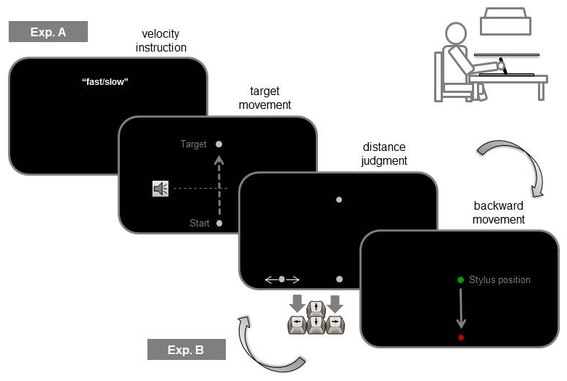
Figure 1. Main trial events and the apparatus (right upper corner) of the present study. After velocity instruction appeared, participants had to press the space bar. Then, the stylus had to be moved from the start to the target position. In 50 % of trials a stop signal was presented during the movement. In Exp. A, a distance estimate was done immediately after the target movement was completed (i.e., before backward movement). In Exp. B, the stylus was moved back to the start before the distance judgment. Note, the stylus position was only visible during the backward movement.

Time of the backward movement
Figure 1 outlines the main trial procedures of Experiment A and of Experiment B. In an initial experiment (Exp. A) the distance judgment was made immediately after movement interruption, i.e. before the hand was returned to the start position. In our earlier studies we demonstrated that an increase in planned movement amplitude increases distance estimates (e.g., Kirsch et al., 2012; see also Introduction). Because the amplitude of the backward movement is larger for unrestricted than for restricted movements in the setup of Experiment A, the predicted decrease in distance estimates for restricted movements might be due to the planning of the backward movement rather than due to the movement interruption per se. We thus, conducted an additional experiment (Exp. B) to control for this possible confound. We basically interchanged the order of the distance judgment and the backward movement.
Error feedback
Under the following conditions an error feedback was presented and the current trial was repeated: When the stylus button was pressed before the stop position was achieved or when the distance between the end position of the stylus and the target fell below 19 mm in the stop trials; when the end position of the stylus deviated by more than 19 mm from the target after the movement in the no stop trials; when the distance judgment was confirmed without moving the horizontal dot; when the stylus was moved away from the start position during the distance judgment (and during the velocity instruction in Exp. B). On average, 14 % of the trials were repeated in Experiment A and 19 % in Experiment B.
Design. The start position was always constant during the experiment, whereas the position of the target slightly varied trial by trial. For slow movements, the stop signal was presented after a half of the target distance (related to Y-coordinates) was covered by the stylus. In order to make the end positions comparable across the slow and fast conditions, the stop signal was presented much earlier during the fast movements. Depending on the current target distance it was presented after exceeding of 11.5, 13.0, 14.3 or 15.5 % of target distance (see below). This was done based on the results of pilot experiments indicating a considerably larger movement extent following the stop signal for fast as compared with slow movements. As shown in Figure S1 (see supplemental materials) the end positions of movements in the present study were comparable for slow and fast conditions. Thus, the variation of the timing of the stop signal was successful.
There were four target distances (98.8, 102.6, 106.4 and 110.2 mm), two stop conditions (stop, no stop) and two velocity instructions (fast, slow; which were varied between the participants, see above). Each experiment (i.e., Exp. A and Exp. B) was divided into two blocks including 40 trials each. In each block, each combination of target distance and stop condition was presented five times in a randomized order. At the beginning of each experiment participants performed 16 practice trials, which were not included in the analyses.
Data analysis. Trials in which distance estimates were below or above 2 SD of the median as computed for each participant, each target distance and each stop condition were excluded from analysis. Overall, 96.8 % (Exp. A) and 97.6 % (Exp. B) of trials entered the analyses.
Results
Table 1 provides an overview of the mean distance estimates across all conditions.
Table 1. Mean distance judgments in Experiment A and Experiment B (in mm)
EXP. A | 98.8 mm |  | 102.6 mm |  | 106.4 mm |  | 110.2 mm
 | no stop | stop | no stop | stop | no stop | stop | no stop | stop
slow | 106.3 (5.9) | 105.5  (6.3) | 109.1 (6.6) | 108.6 (6.6) | 113.3 (7.6) | 112.2 (8.0) | 116.2 (7.3) | 115.6 (8.3)
fast | 108.4 (7.6) | 109.0 (6.6) | 113.3 (7.0) | 112.8 (7.5) | 116.3 (8.1) | 114.4 (7.5) | 121.2 (8.3) | 120.1 (9.2)
EXP. B
slow | 111.5 (6.6) | 110.5 (5.7) | 114.8 (6.4) | 113.7 (6.7) | 118.6 (7.1) | 117.6 (6.5) | 122.4 (7.0) | 121.8 (7.7)
fast | 110.8 (7.0) | 111.0 (6.4) | 113.9 (7.4) | 114.0 (6.6) | 118.2 (8.1) | 117.9 (7.5) | 122.6 (7.0) | 121.6 (7.6)
Note. Standard deviations are in parentheses.

An analysis of variance (ANOVA) including target distance and stop condition as within-participants factors and velocity instruction as a between-participants factor revealed significant main effects of target distance and of stop condition for Exp. A, F(3, 66) = 193.7, p < .001, η_{p}²= .898, and F(1, 22) = 5.4, p = .029, η_{p}²= .198, as well as for Exp. B., F(3, 66) = 260.2, p < .001, η_{p}² = .922, and F(1, 22) = 5.2, p = .032, η_{p}² = .192. Neither velocity instruction nor interactions reached the significance threshold (all p > .064).
Judgments increased with distance as expected (cf. Table 1). More importantly, after movement interruption participants decreased their estimates as compared with judgments made after unrestricted movements (see left part of Fig. 2 for means). This rather small but systematic effect was present in both experiments. Unlike our previous experiments using mechanical movement interruption movement speed proved to have no systematic impact on judgment behavior.
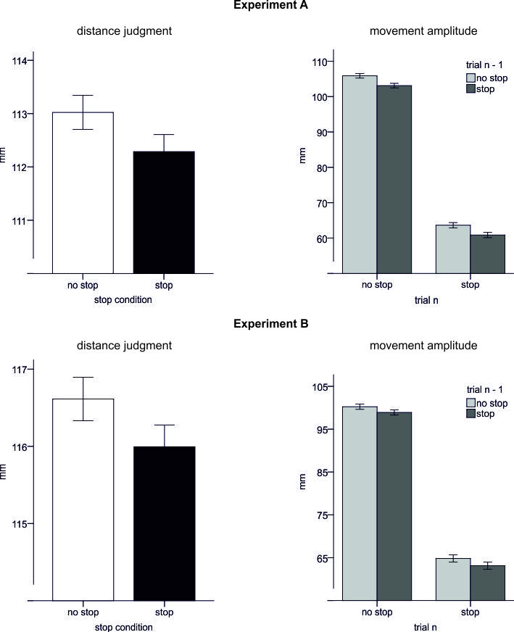

Figure 2. Main results of Experiment A (top) and Experiment B (bottom). Left: Mean distance estimates for each stop condition. Right: Mean movement amplitude depending on whether the previous trial (n - 1) contained the same or a different stop condition. Note, error bars reflect within participants confidence intervals (95%) computed according to Cousineau (2005).

We also examined how movement interruption affected the motor behavior in a subsequent trial. Unlike the classical stop-signal paradigm the temporal aspects of responses in the more complex task of the present study were not rigorously controlled. In particular, movement trajectories were not recorded and there was no speed instruction for the pressing the stylus button after movement was completed (or stopped). So we had no reliable measure of movement time (or of stop signal reaction times). Thus, we focused on movement amplitude which is an indicator of the motor commands used to achieve a given target.
For stop trials it indicates how cautious the participants are during movement execution (i.e., how fast they are and / or how much force they apply). Fast movements are usually more difficult to stop than slow movements (cf. also e.g., Bissett & Logan, 2011). In the present study, e.g., the stop signal was presented much earlier for fast than for slow movements as mentioned earlier (at about 14% vs. 50 % of the trajectory). In spite of this, the movement amplitude was similar for both velocity conditions (cf Figure S1). Accordingly, an increase of movement speed and/or force during the stop-trials has to be associated with an increase in difficulty to stop the movement. As a consequence, an increase in the amplitude of a movement finished in response to a stop-signal will speak for a decrease of caution in planning and control strategies (i.e., for an increase of speed and / or force).
For no stop trials, in contrast, movement amplitude informs about a current sensory-motor mapping. In the absence of the stop signal the task was to reach the current target position. Because no visual feedback was provided until the movement was finished, the end position of the movement (i.e. movement amplitude) can be considered as indicative of planned movement extent required to achieve a given target (i.e., of the current calibration between motor and visual representations).
Here, we defined movement amplitude as the linear distance between the start position and the end position of the movement along the Y-axis of the tablet. The amplitude of the movement performed after stop trials was compared with the amplitude of the movement performed after no stop trials by means of an ANOVA including stop condition in a given trial n and stop condition in trial n-1 as factors. This analysis revealed significant main effects for the stop condition in trial n-1 for Exp. A as well as for Exp. B with F(1, 23) = 33.6, p < .001, η_{p}² = .593 and F(1, 23) = 9.4, p = .005, η_{p}² = .291 respectively. This effect was due to smaller movement amplitude after stops trials than after no stop trials (see Fig. 2, right part). Pairwise comparisons suggested further that this effect held for restricted as well as for unrestricted movements of trial n, t(23) = 3.9, p = .001 and t(23) = 4.5, p < .001 for Exp. A, and t(23) = 2.1, p = .052 and t(23) = 2.3, p = .033 for Exp. B.

Discussion
We asked whether cognitive adjustment processes associated with inhibition of goal directed movements are accompanied by changes of apparent target distance. Participants performed hand movements trying to reach a target initially. These movements were either interrupted after a stop-signal before the target was achieved or were unrestricted. A decrease of perceived distance after interrupted compared with unrestricted movements was predicted due to an assumed functional role of perception for action: after movement interruption perception may signal to the actor to be more cautious during a subsequent action in the present setup. The results were in line with this prediction.
Distance judgments following interrupted movements decreased as compared with unrestricted movements. Moreover, we found that movement amplitude in a current trial was affected by the stop condition of the previous trial: it was smaller following movement interruption than following unrestricted movements. This last result suggests that participants performed movements with more caution after stop trials as expected. This is indicated by the shorter amplitudes in the stop trials following stop trials. Moreover, the shorter amplitude following stop trials observed in no-stop trials might also indicate a changed mapping between visual stimuli and movements. In particular, a smaller movement extent might have been associated with a given visual distance after restricted than after unrestricted movements. This would speak for that movement interruption induced a short-term recalibration between the optical information associated with the target position and the motor command required to achieve this position. Also, it is in line with changes in visual perception observed in the preceding trial and their assumed (signal) function. In other words, smaller movement amplitude here might be a consequence of perceiving the previous target as closer.
Thus, the results as a whole seem to delineate a type of visual illusion which helps to optimize planning of future actions: it appears to inform about how to move by means of a subjective distortion. We assume that the underlying mechanism is related to strategic adjustments of the motor plan used to achieve a given visual target. In particular, movement interruption indicates to the participant that the motor output is inappropriate. This conflict will be resolved by an updating of the initial motor plan. According to the core assumption of action specific accounts of perception visual stimuli are perceived in terms of motor units (e.g., Proffitt & Linkenauger, 2013). Thus, changes in the motor plan cause changes in perception (see also Introduction).
Such a mechanism resembles to some extent a “conflict-induced perceptual filtering” suggested earlier (Wendt, Luna-Rodriguez, & Jacobsen, 2012). According to this account perceptual system can be adjusted depending on the degree of cognitive conflict induced, e.g., in the Eriksen flaker task. For instance, an increase of a congruent/incongruent ratio may enhance the efficiency of processing of stimuli serving as flankers and / or reduce the efficiency of processing of stimuli serving as targets. Thus, perceptual processing is assumed to change as a result of the attempt to resolve a cognitive conflict (cf. also Egner & Hirsch, 2005).
So far we assumed that strategic performance adjustments are the primary cause of perceptual changes observed in the present setup. This assumption seems justified given the evidence for strategic post-stop-signal adjustments within the stop-signal paradigm (e.g., Bissett & Logan, 2012; Verbruggen & Logan, 2009). Nevertheless, other explanations are possible. For example, a decrease in distance estimates following movement interruption (as well as variations of subsequent movements) might be an after-effect of motor inhibition, rather than be directly related to behavioral control adjustments (cf. e.g., Verbruggen, et al., 2008). That is, breaking an ongoing movement could per se decrease the perceived target distance. For instance, distance perception can be modified when the uncertainty (i.e., noise) within the sensorimotor system increases (Bourgeois & Coello, 2012). Accordingly, the observed decrease of distance judgments for restricted movements may result from increased sensorimotor variability due to movement interruption rather than from processes associated with performance adjustments as we suggested. The present study cannot distinguish between these possible mechanisms and further research is needed to examine the exact origin of the observed effects.
To sum up, the present results show, in our knowledge for the first time, that an action related change in visual perception is followed by adjustments of successive behavior which are in line with a changed perception and which are consistent with a strategic adaptation to given task demands. However, further studies are needed to better evaluate to what extent the relation between changes in perception and successive behavior is causal.

References
Bissett, P. G., & Logan, G. D. (2011). Balancing cognitive demands: Control adjustments in the Stop-signal paradigm. Journal of Experimental Psychology: Learning, Memory, and Cognition, 37(2), 392-404.

Bissett, P. G., & Logan, G. D. (2012). Post-stop-signal slowing: Strategies dominate reflexes and implicit learning. Journal of Experimental Psychology: Human Perception and Performance, 38(3), 746-757.

Botvinick, M., Braver, T., Barch, D. Carter, C. & Cohen, J. (2001). Conflict monitoring and cognitive control. Psychological Review, 108 (3), 624-652.

Bourgeois, J., & Coello, Y. (2012). Effect of visuomotor calibration and uncertainty on the perception of peripersonal space. Attention, Perception and Psychophysics, 74(6), 1268-1283.

Cousineau, D. (2005). Confidence intervals in within-subject designs: A simpler solution to Loftus and Masson's method. Tutorials in Quantitative Methods for Psychology, 1, 75-78.

Egner, T., & Hirsch, J. (2005). Cognitive control mechanisms resolve conflict through cortical amplification of task-relevant information. Nature Neuroscience, 8(12), 1784-1790.
Gordon, J., & Ghez, C. (1987). Trajectory control in targeted force impulses. II. Pulse height control. Experimental Brain Research, 67, 241-252.

Kirsch, W., Hennighausen, E., & Rösler, F. (2009). Dissociating cognitive and motor interference effects on kinesthetic short-term memory. Psychological Research, 73, 380-389.

Kirsch, W., Henninghausen, E., & Rösler, F. (2010). ERP correlates of linear hand movements in a motor reproduction task. Psychophysiology, 47(3), 486-500.

Kirsch, W., Herbort, O., Butz, M. V., & Kunde, W. (2012). Influence of motor planning on distance perception within the peripersonal space. PLoS ONE, 7, e34880. doi:10.1371/journal.pone.0034880

Kirsch, W., & Kunde, W. (2013a). Visual near space is scaled to parameters of current action plans. Journal of Experimental Psychology: Human Perception & Performance, 39(5), 1313-25.

Kirsch, W., & Kunde, W. (2013b). Moving further moves things further away in visual perception: Position-based movement planning affects distance judgment. Experimental Brain Research, 226(3), 431-440.

Kirsch, W., & Kunde, W. (2014). Impact of planned movement direction on judgments of visual locations. Psychological Research, 78, 705-720.

Kornblum, S., Hasbroucq, T., & Osman, A. (1990). Dimensional overlap: cognitive basis for stimulus-response compatibility – a model and taxonomy. Psychological Review, 97(2), 253-270.

Logan, G.D., & Cowan, W. B. (1984). On the ability to inhibit thought and action: A theory of an act of control. Psychological Review, 91, 295-327.

Messier, J., & Kalaska, J. F. (1999). Comparison of variability of initial kinematics and endpoints of reaching movements. Experimental Brain Research, 125, 139-152.

Proffitt, D.R. (2006). Embodied perception and the economy of action. Perspectives on Psychological Science, 1(2), 110-122.

Proffitt, D.R. (2008). An Action Specific Approach to Spatial Perception. In R. L. Klatzky, B. MacWhinney & M. Behrmann (Eds.), Embodiment, Ego-Space, and Action. New York: Psychology Press.

Proffitt, D.R., & Linkenauger, S.A. (2013). Perception viewed as a phenotypic expression. In: W. Prinz (Ed), Tutorials in Action Science. MIT Press, Cambridge. pp. 171-198.

Van Beers, R.J. (2009). Motor learning is optimally tuned to the properties of motor noise. Neuron, 63, 406-417.

Verbruggen, F., & Logan, G. D. (2008). Response inhibition in the stop-signal paradigm. Trends in Cognitive Sciences, 12, 418-424.

Verbruggen, F., & Logan G.D. (2009). Proactive adjustments of response strategies in the stop-signal paradigm. Journal of Experimental Psychology: Human Perception and Performance, 35, 835-854.

Verbruggen, F., Logan, G. D., Liefooghe, B., & Vandierendonck, A. (2008). Aftereffects of response inhibition: Repetition priming or between-trial control adjustments? Journal of Experimental Psychology: Human Perception and Performance, 34, 413-426.

Wendt, M., Luna-Rodriguez, A., & Jacobsen, T. (2012). Conflict-induced perceptual filtering. Journal of Experimental Psychology: Human Perception and Performance, 38, 675-686

Witt, J.K. (2011a). Action’s effect on perception. Current Directions in Psychological Science, 20(3). 201-206.

Witt, J.K. (2011b). Tool use influences perceived shape and perceived parallelism, which serve as indirect measure of perceived distance. Journal of Experimental Psychology: Human Perception and Performance, 37(4), 1148-1156.

Witt, J.K., Linkenauger, S.A., & Proffitt, D.R. (2012). Get Me Out of This Slump! Visual Illusions Improve Sports Performance. Psychological Science, 23(4), 397-399.

Witt, J.K., & Proffitt, D. R. (2008). Action-specific Influences on Distance Perception: A Role for Motor Simulation. Journal of Experimental Psychology: Human Perception and Performance, 34(6), 1479-1492.

Witt, J.K., Proffitt, D.R., & Epstein, W. (2005). Tool use affects perceived distance but only when you intend to use it. Journal of Experimental Psychology: Human Perception and Performance, 31(5), 880-888.
Wood, G., Vine, S.J., & Wilson, M.R. (2013). The impact of visual illusions on perception, action planning, and motor performance. Attention, Perception, & Psychophysics, 75, 830-834.

Acknowledgments
This research was supported by grant KI 1620/1-1 awarded to W. Kirsch by the German Research Council (DFG).

Such a sensory-motor coupling can be mediated by a process of motor simulation as suggested by Witt and Proffitt (2008).
The stylus position was only displayed during the backward movement (green dot in Fig. 1).
This and similar methods have been often applied by us and others in related contexts (e.g., Kirsch & Kunde, 2013a, Kirsch & Kunde, 2013b; Witt & Proffitt, 2008; Witt, Proffitt, & Epstein, 2005).
This ensured that movements were stopped after the stop signal and before the target was reached.
This marginally significant p value corresponded to an interaction between target distance and velocity instruction in Exp. A and suggested that there was a distance specific trend towards larger distance estimates for the participants getting the fast movement instruction (cf. Table 1; other p values > .22).
This hypothesis roots in the conflict monitoring model of Botvinick et al., (2001) assuming attentional biasing of perceptual processes as a function of the degree of the previous conflict. Our conclusions are thus also compatible with this model.

